UNIT 6 JOBS
OUTLINE

1 Language Development
1.1 have /has to
1.2 Adjective phrases
1.3 Grammar for writing:
- must and have to
- Joining sentences with and
2 Vocabulary
2.1 Vocabulary for jobs: suffixes
2.2 Adjectives for people
2.3 Collocations for jobs
3 Critical thinking
3.1 Choose criteria
3.2 Complete a questionnaire
3.3 Choose a job based on Questionnaire results
4 Input
4.1 Listening
4.1.1 Listening for opinion
4.1.2 Predicting content
4.1.3 Understanding key vocabulary
4.1.4 Listening for main ideas
4.1.5 Listening for detail
4.2 Reading
4.2.1 Reading for detail
4.2.2 Previewing
4.2.3 Understanding key vocabulary
4.2.4 Scanning to find information
4.2.5 Working out meaning from context
5 Output
5.1 Speaking task:
Choose a person for a job
5.2 Academic writing skills:
Contractions
5.3 Writing task:
Write a description of a job for a friend

EXERCISES

- Listen to part of a discussion. Choose True or False.
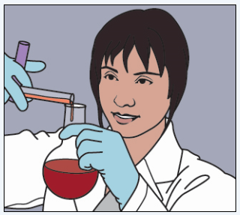

 | True  (T) | False  (F)
Ahmed says that policewomen have to be polite and helpful.
Ahmed says that you don't have to go to medical school to be a doctor.
Ahmed says that bankers and scientists have to be good at maths.
Ahmed says that scientists can make a lot of money.
Ahmed says that LingLing can help her family if she has a lot of money.
Faisal agrees with Ahmed.
- Correct the mistakes in the statements.
- Students have read a lot of books.

- My teacher have to walk to school.

- You don’t have study English.

- Teachers don’t to work at night.

- Have we learn this grammar?

- What does a nurse has to do?

- Join the phrases to make sentences.
An accountant | looks after animals | in hospital.
A window cleaner | flies spacecraft | in towns and cities.
A builder | gives people medicine | in space.
A chef | looks after passengers | in farms and zoos.
A doctor | looks after money | to different countries.
A pilot | prepares food | in a company.
A fireman | builds houses | in a restaurant.
A flight attendant | puts out fires | on buildings.
An astronaut | cleans windows | on a plane.
A vet | flies planes | in towns and cities.

- An accountant ___________________________________________
- A window cleaner ________________________________________
- A builder _______________________________________________
- A chef _________________________________________________
- A doctor _______________________________________________
- A pilot _________________________________________________
- A fireman ______________________________________________
- A flight attendant ________________________________________
- An astronaut ____________________________________________
10) A vet __________________________________________________

4. Reading
Is your job boring? Here are some different jobs you might like.
Zookeeper
A zookeeper must like animals. The work is hard and you have to get up early and work long hours. You have to wear a uniform but you don't have to keep it clean. Feeding and cleaning animals can be messy work!
Astronaut
An astronaut must be fit and healthy. Astronauts have to know about a lot of things. They have to know about science and how to fly spacecraft. They also have to train for many years. Astronauts don't have to be men. There are now many women astronauts, too.
Window cleaner
Window cleaners must be fit. They also have to have strong arms. Cleaning tall buildings is dangerous. Window cleaners have to wear safety equipment. They must like heights.
Pet detective
Pet detectives help people find their missing animals. Pet detectives must be friendly because they speak to a lot of people. They also have to use computers. Finding missing pets is difficult. Pet detectives have to be patient. They don't usually have to wear a uniform.

- Read the text. Write true (T) or false (F) next to the statements.
- ___ Zookeepers don't have to wear a uniform.
- ___ Astronauts have to know how to fly spacecraft.
- ___ Astronauts must be men.
- ___ Window cleaners have to clean tall buildings.
- ___ Pet detectives have to wear a uniform.
- Read the text again. Write (Z) for zookeeper, (A) for astronaut, (W) for window cleaner or (P) for pet detective next to each statement.
- ___ He/She must work long hours
- ___ He/She has to train for a long time
- ___ He/She has to get up early.
- ___ He/She must be good with people.
- ___ He/She must be fit and strong

- Writing task: Write a description of a job for a friend.
- Do the questionnaire: read the statements and circle the answer that is true for you.
1 = strongly disagree
2 = disagree
3 = neither agree nor disagree
4 = agree
5 = strongly agree
1 I am very healthy. | 1 | 2 | 3 | 4 | 5
2 I am fit and strong. | 1 | 2 | 3 | 4 | 5
3 I am good with people. | 1 | 2 | 3 | 4 | 5
4 I am very patient. | 1 | 2 | 3 | 4 | 5
5 I am kind and helpful. | 1 | 2 | 3 | 4 | 5
6 I am good with children. | 1 | 2 | 3 | 4 | 5
7 I am very smart. | 1 | 2 | 3 | 4 | 5
8 I am good at Maths. | 1 | 2 | 3 | 4 | 5
9 I am very creative. | 1 | 2 | 3 | 4 | 5
10 I am good with computers. | 1 | 2 | 3 | 4 | 5
11 I am good with animals. | 1 | 2 | 3 | 4 | 5
12 I am good at foreign languages. | 1 | 2 | 3 | 4 | 5

- Work with a partner. Send your questionnaire to your partner. Read your partner’s answers to the questionnaire. Write information about a job for your partner in the email below.

To:
From:
Subject:
Dear ____________ (write your partner’s name),
I hope you’re well. I have a great job for you. I think you’ll like it – it’s in ________________________________________________ (write the name of country)!
The job is in ________________________________________________ (write the name of the city/town). It ______________________________
___________________________________________________________
(write a sentence to describe the city).
The job is for a ________________________ (write the name of the job). It’s ____________________________________ (write full-time or part-time). The salary is __________________ (write the salary) per month.

(Write sentences about the job. Use must and have to with adjective phrases.)
Here’s the link: www.discoverjobs4you.com
Good luck!
___________________________(write your name)

- Use the task checklist to review your sentences.
TASK CHECKLIST | ✔
Do your sentences use must and have to to say that something is necessary?
Do your sentences use do / does not have to to say that something is not necessary?
Do your sentences use adjective phrases to describe a job applicant?
Do your sentences use contractions?

6 Speaking task: choose a person for a job.
The staff of University of Yukon Sports Centre is going to recruit a nurse. Imagine you are one of the candidates for the job vacancy. Read the applications and highlight the key information that appeals to you. You are required to record your reading and upload the audio file.

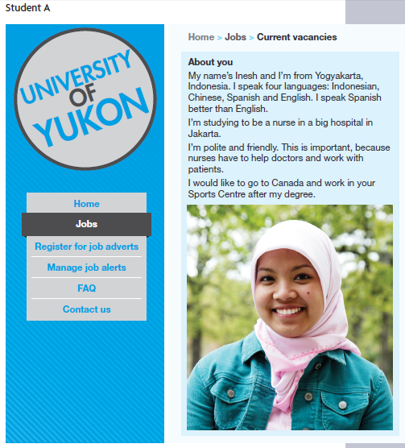

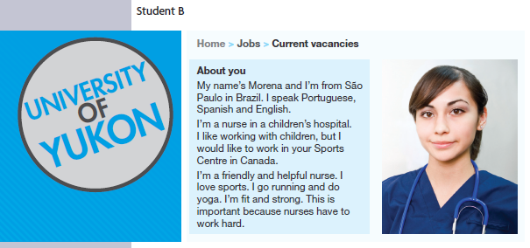

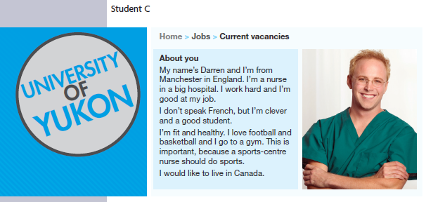

KEYS

- F, F, T, F, T, T
Q1: False – Ahmed says that 'Policewomen have to be fit and strong.'
Q2: False – Ahmed says that 'You have to go to medical school to be a doctor.'
Q4: False – Ahmed says that bankers 'can make a lot of money.'
Audio script:
Faisal: … reading books and playing computer games. So what do you think she should do?
Ahmed: Well, I don't think she should be a policewoman. Policewomen have to be fit and strong. And I don't think she should be a doctor. You have to go to medical school to be a doctor.
Faisal: Yes, I think you're right.
Ahmed: I think she should be a scientist or a banker. You have to be good at maths to do those jobs.
Faisal: Yes, you're right. But which one?
Ahmed: I think she should be a banker.
Faisal: Why?
Ahmed: Because they can make a lot of money. If she has a lot of money, she can help her family and her friends and she can have a good life.
Faisal: Yes, I agree. I think you're right.

2.
1) Students have to read a lot of books.
2) My teacher has to walk to school.
3) You don’t have to study English.
4) Teachers don’t have to work at night.
5) Do we have to learn this grammar?
6) What does a nurse have to do?

3.
1) An accountant looks after money in a company.
2) A window cleaner cleans windows on buildings.
3) A builder builds houses in towns and cities.
- A chef prepares food in a restaurant.
- A doctor gives people medicine in hospital.
- A pilot flies planes to different countries.
- A fireman puts out fires in towns and cities.
- A flight attendant looks after passengers on a plane.
- An astronaut flies spacecraft in space.
- A vet looks after animals in farms and zoos.

4.
1) a-e F, T, F, T, F
2) a-e Z, A, Z, P, W

5 – 6 As subjective tasks, there are no suggested answers for them.

Appendix: Worksheet for the speaking class.

以下是听说直播课的部分讲义，建议你提前预习，做好听课准备。

LET’S TALK: Choose a person for a job
- After the Q & A, write down key information on your worksheet.
question | Inesh | Morena | Darren
1
2
3
4
5

